Website Link: https://charterclubofmarcoisland.com/
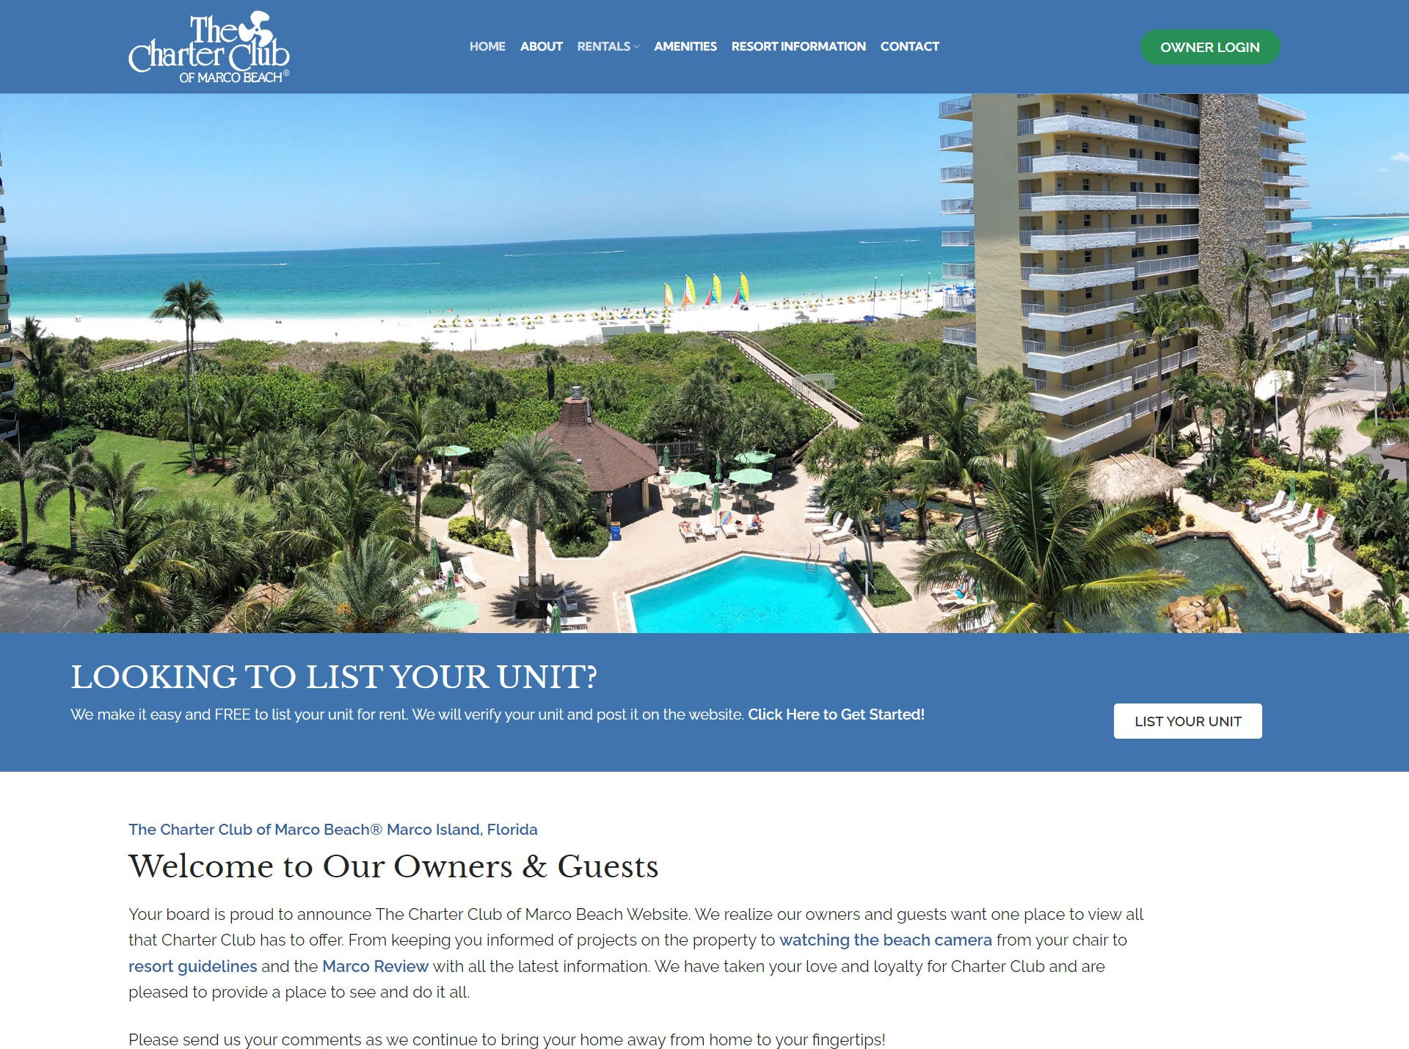

Welcome to the Charter Club of Marco Beach! This guide will show you how to:

- Login to the Owner Area
- Access Online Forms
- Signup for Owner Email Alerts
- List Your Unit for Rent

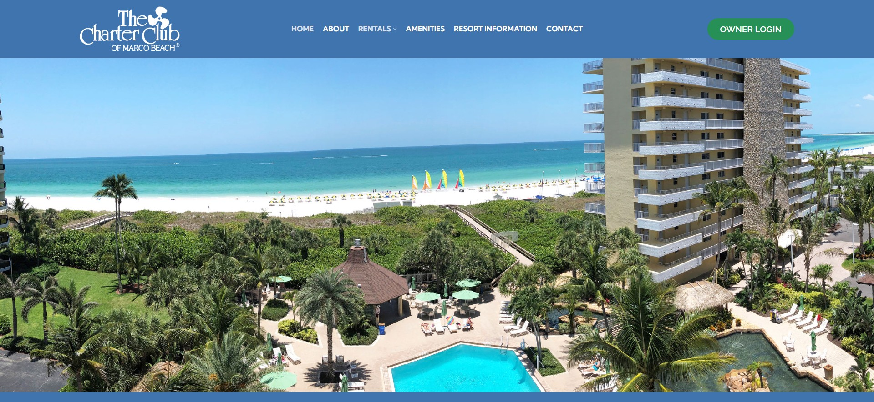
Accessing the owner area of the website is easy!
The first step is to click on the green button in the main menu that says “OWNER LOGIN”

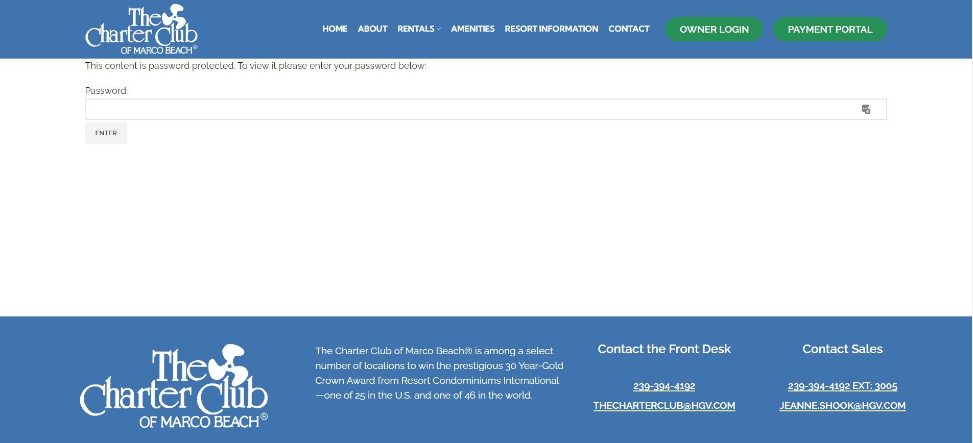
After you click on the “OWNER LOGIN” button, you’ll be taken the owner login page of the website
  - Enter your password to login and make sure you keep your password in a safe place.
Now that you are logged in, you have full access to the Owner’s Area of the website. In order to access online forms, the first step is to be logged in to Owner’s Area of the website.
Online Forms can be found at bottom of the Owner Login page. Once you login scroll to the bottom of the page and look for the section called “What Are You Looking For?

Listing Your Unit for Rent

You can list your unit for rent by clicking the List You Unit button on the home page, or going to https://charterclubofmarcoisland.com/list-unit-for-rent/
From here you will find everything you need to list your unit.

See Available Rentals

You can see available rentals by clicking the Available Rentals button on the home page, or going to https://charterclubofmarcoisland.com/available-rentals/

Opting In for Owner Email Alerts

If you want to opt-in for Owner Email alerts, you need to scroll to the bottom of the homepage. There you will find a Opt-In for Owner Email Alerts Sign-up Form
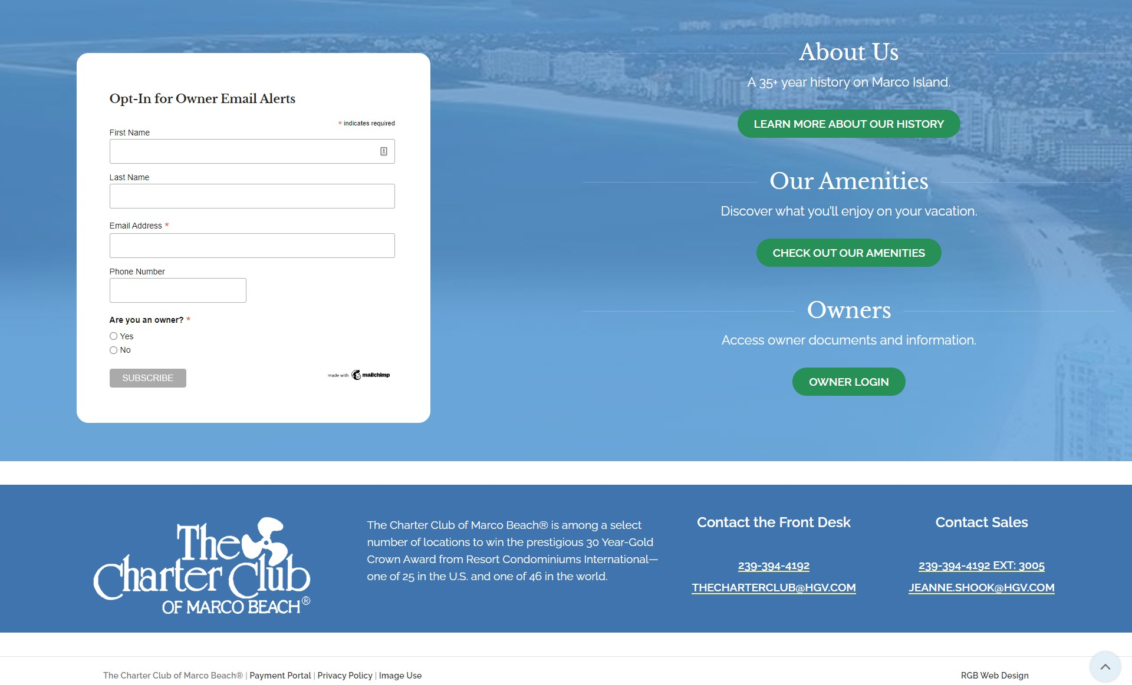

Congrats, you have successfully logged in to the Owner’s Area of the website and now know how to access some important features!

Remember to keep your password in a safe place and please refrain from sharing your password with others in order to keep the website secure.

Phone Number: 239-394-4192
Email: charterclubowners@hgv.com

